Group 6

Group Members: Jun Li, Rui Xi

**Hand Gesture and Finger Detection**

***Abstract***

Hand gesture and fingertip recognition provides us a new way to interacting with computer devices. This work introduces a simple approach for hand gesture recognition. The hand gesture region is extracted from the original input hand gesture image and then processed by the algorithm to calculate the distance from the fingertip to the center of the hand area in order to determine the number of actual fingers in the image and to reach the recognition goal.

***Introduction***

The objective is to implement a hand gesture recognition and fingertip detection method, which can be further assisted in hand gesture control over computers and other devices instead of clicking a mouse or touching a screen physically. In this work, we implement a proposed method of gesture recognition and fingertip detection and made improvements based on R. M. Prakash’s paper on website IEEE ("Gesture recognition and fingertips detection for human computer interaction,"). The paper shows that the first step of the method according to the paper is to capture hand gesture RGB video by real time camera. Then, we can extract the individual frames out of the video captured by the camera. Next, after convert the image to grayscale, we do region growing segmentation of the image to extract the background region and leave the hand region only. The following step is to find the radius and the center of the hand region we get and use convex hull algorithm to find the biggest polygon including all vertices. The segmentation is used to detection hand region and the convex hull algorithm enables us to detect fingertip. The longest vertex will be identified as the index finger. Thus, now we are able to detect and identify 5 different hand gestures. An example is showing in the figure below:

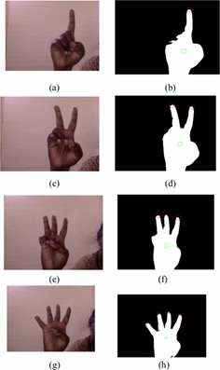

***Related Work***

There are attempts to develop pose and detection methods or systems have been made in the past. An example related to finger detection is Biswas’s method to recognize human body motions ("Gesture recognition using Microsoft Kinect") by Microsoft. This method consists in the background subtraction by using one kind of auto-thresholding method on its depth histogram. It then shows on a grid that the motion information of a body pose will be displayed on the cell of the grid as shown below. And they train the system for the classification by using a multi class Support Vector Machine.

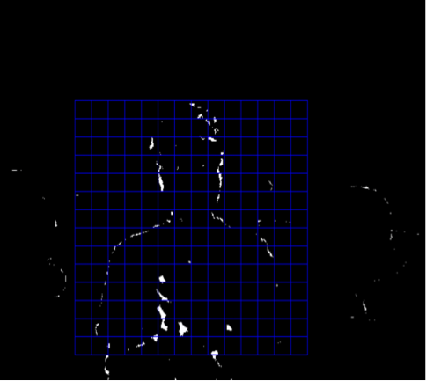

Since they are only using simple depth images, it would be relatively easy to extend it to large amount of gestures and it would be possible to classify and recognize hand gestures. And the method is also pretty efficient in time since it does not involve many calculations.

***Implementation***

*- Subtracting the background*

To implement this work, we use detection of sample hand gesture images of one finger to five fingers, which can be edited to real-time videos by built-in webcam or camera for future use. Next, we separate the hand area of the hand gesture image from the background as showing below by using the color based segmentation, and we choose to repeat the clustering 3 times to avoid local minima.

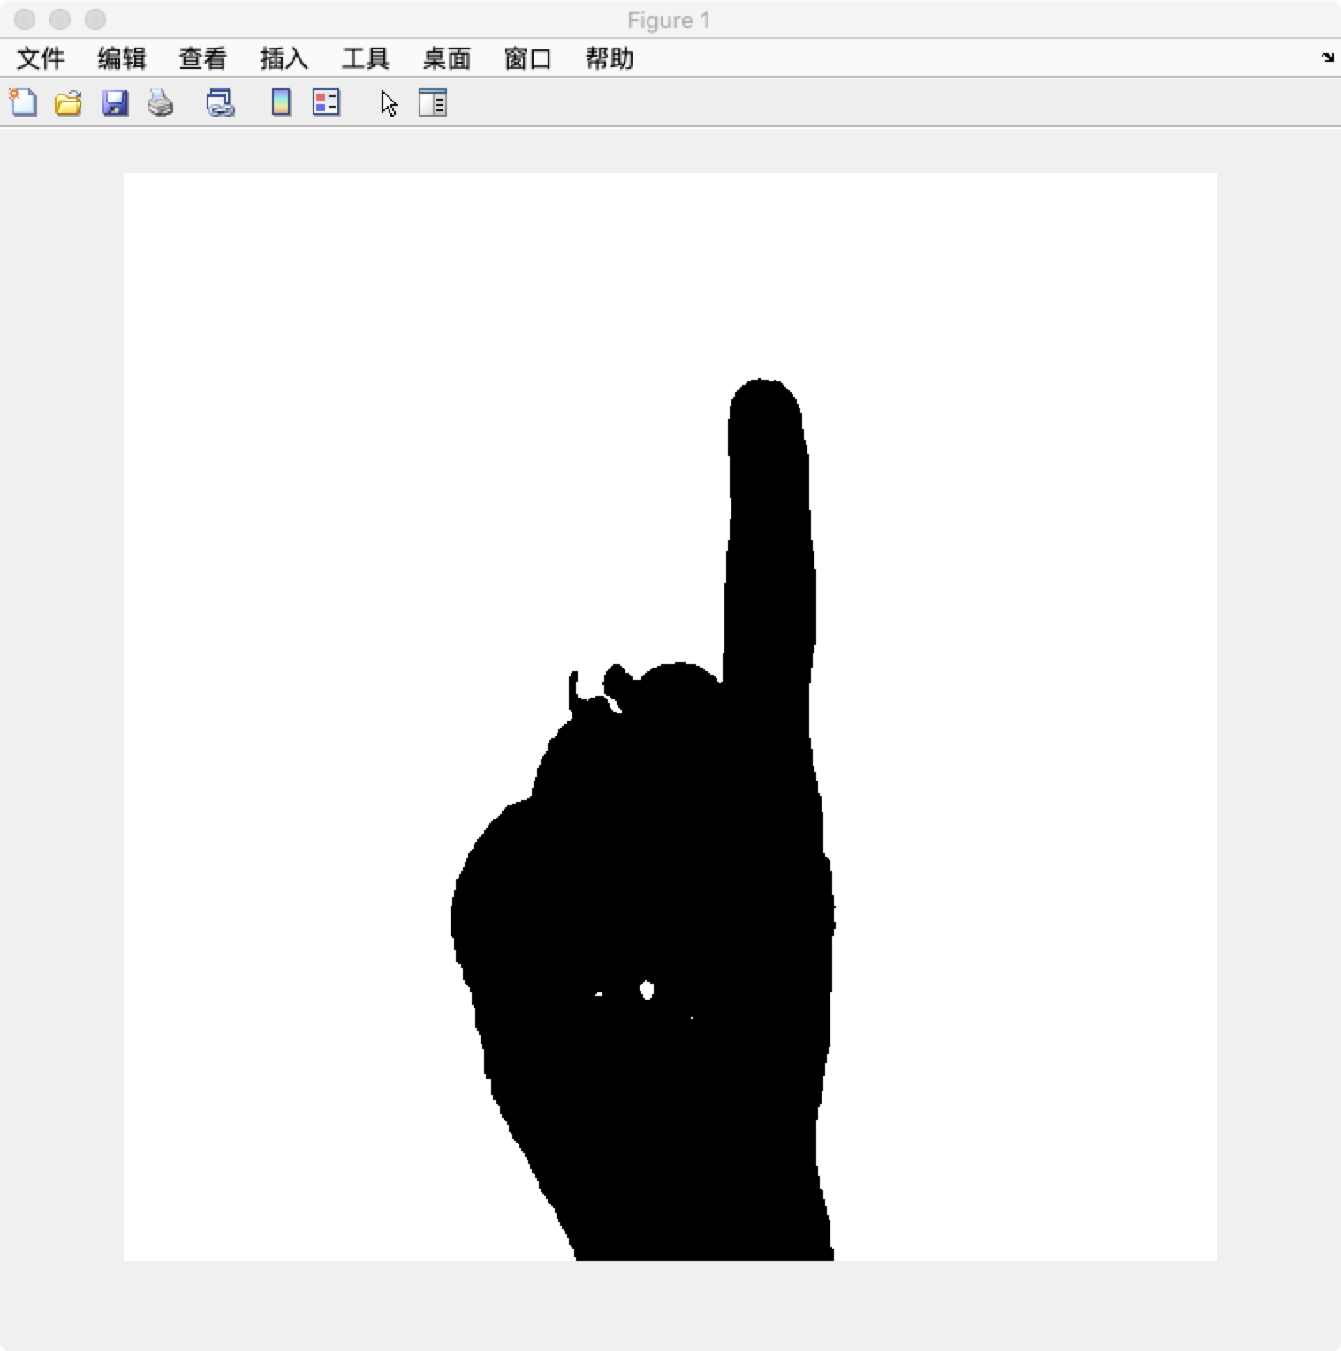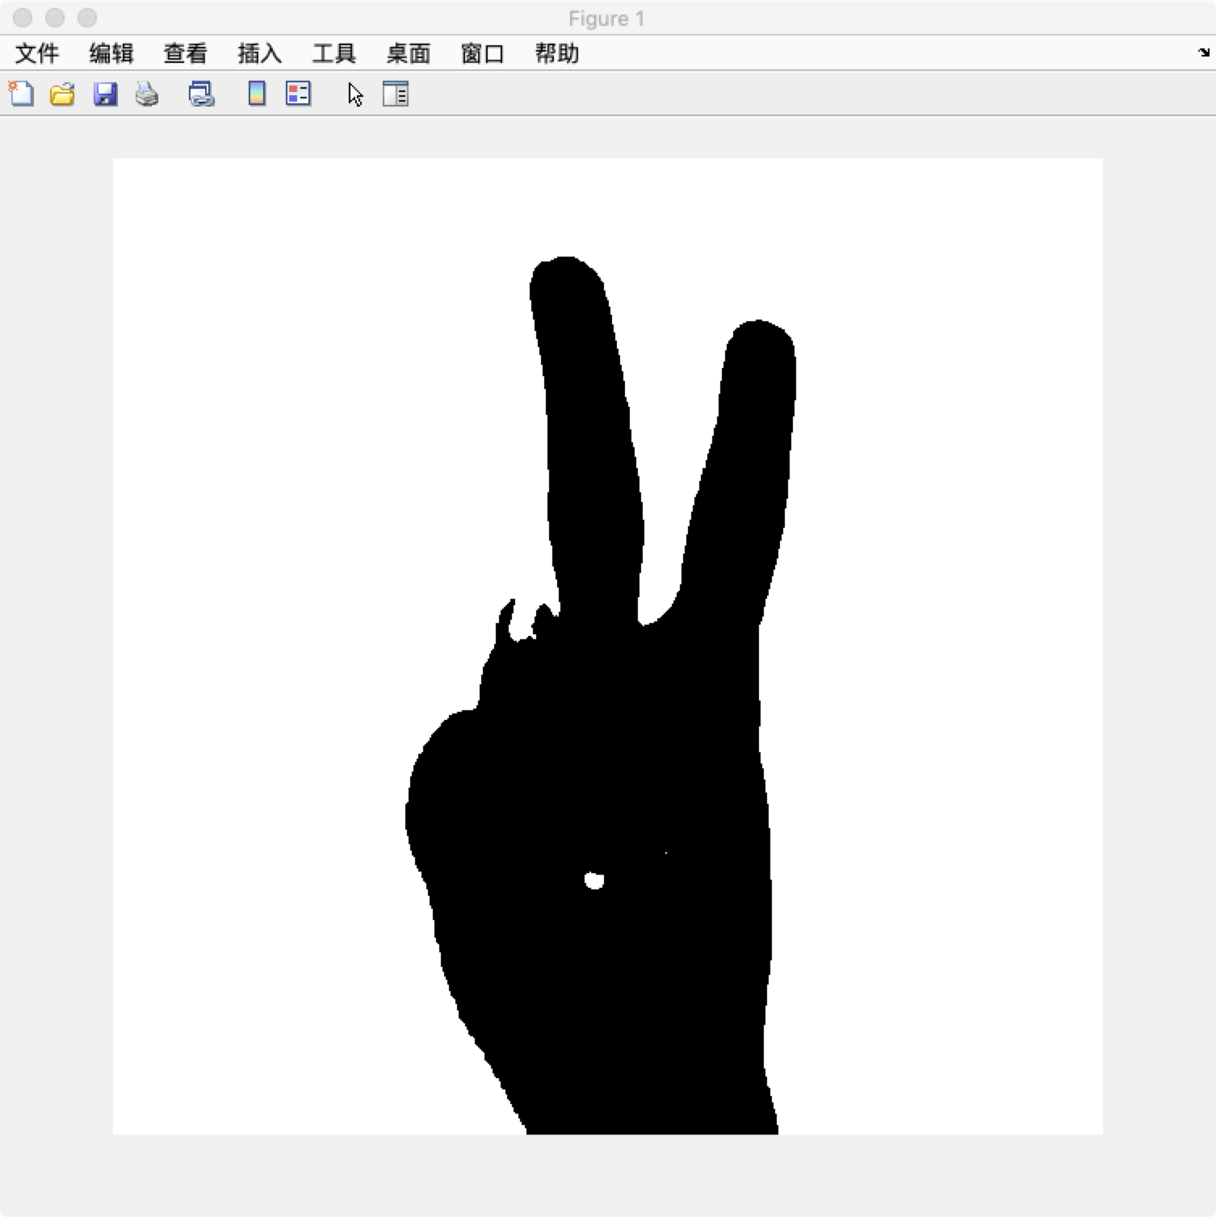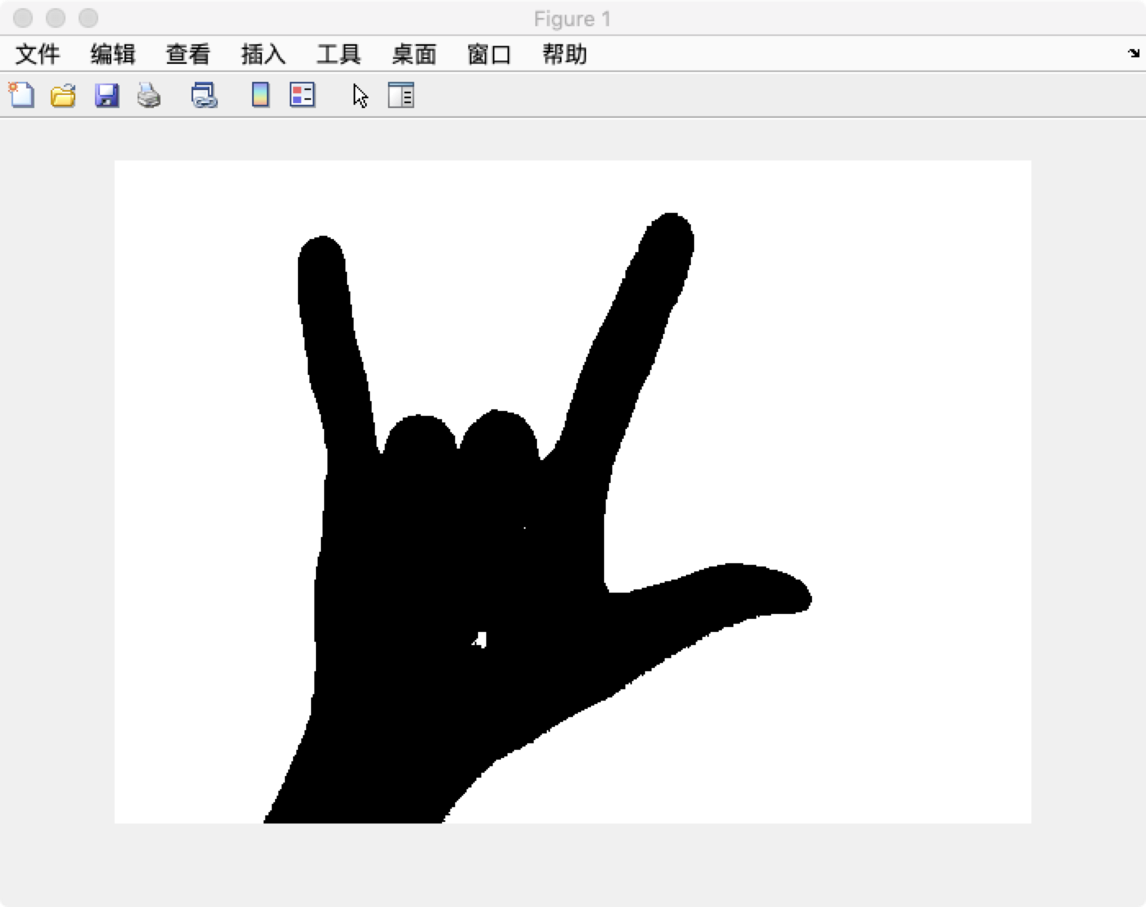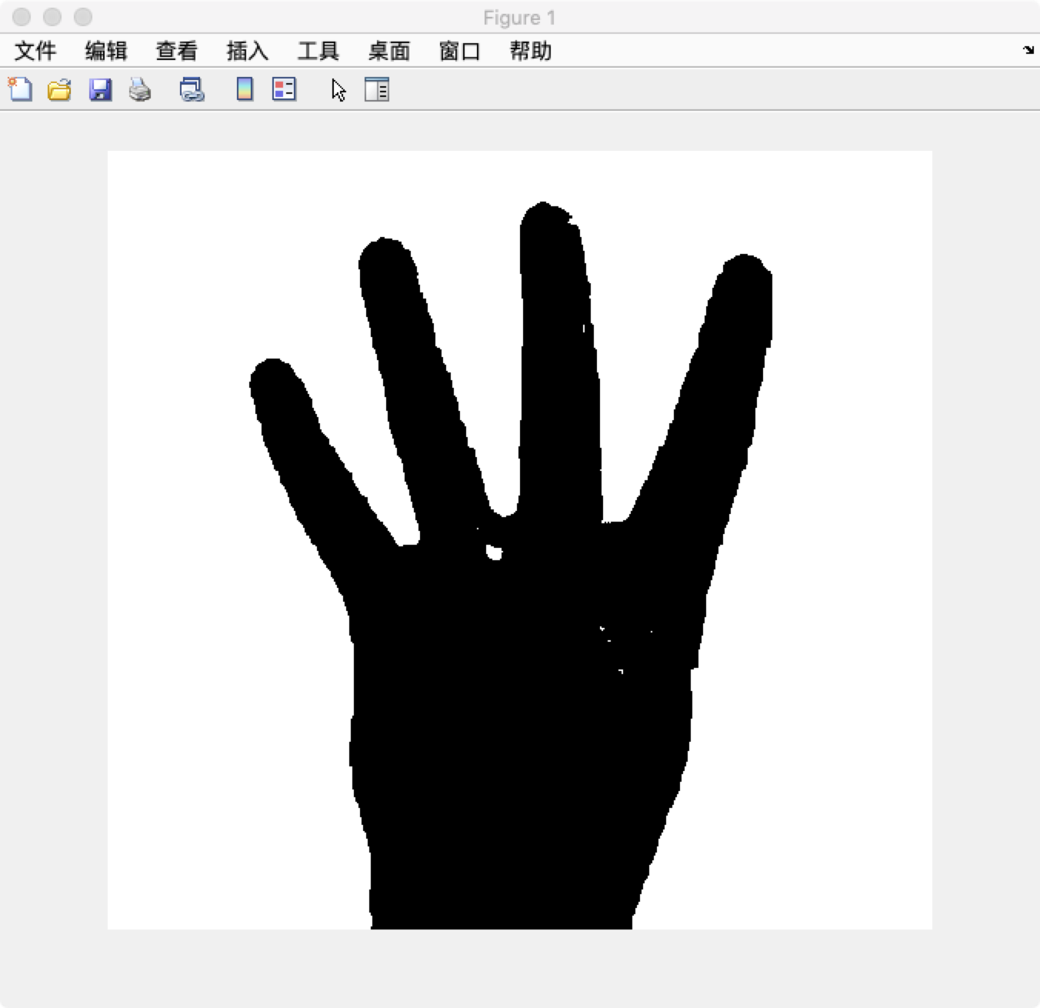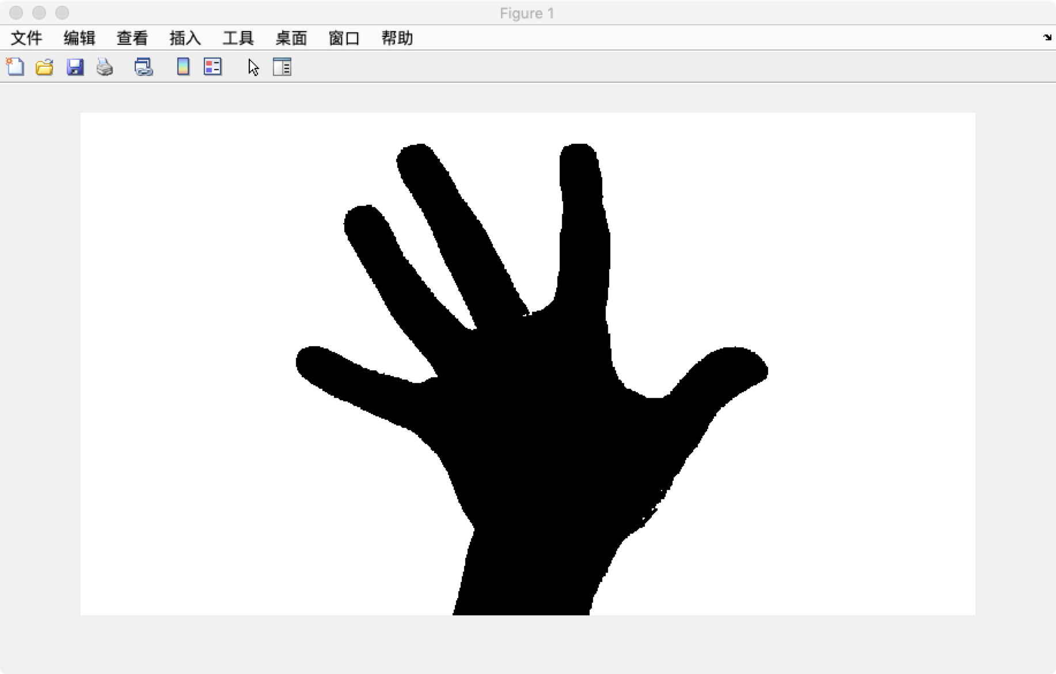

*- Getting the center of the palm*

Then we will find the center of hand region by equations below:

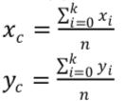

Where (Xc, Yc) is the center of the hand region and (Xi, Yi) is the ith pixel in hand region, and n is the number of pixels in hand region.

*- Getting the convex hull of hand area*

We used *find* function to get the X and Y subscriptions of hand area, and the used *convhull* function to get all the convexes that contour the smallest polygon includes all the points. By setting a threshold of distance between clusters, we cluster the convexes and used the farest convex (to the center) of each cluster to represent the clusters, to make sure the convex is on the tips of fingers. Also it brings more accuracy when we identify the fingertips, which will be explained later.

However, for the blue points we got, we also have the contours of the palm sometimes as well as the wrist line (at the edge of input image). We identify the wrist by checking the cluster with most convexes, since only the wrist cluster is a large amount of convexes consisting a line.

These are examples of this step, from convex hull (left) to representative convexes.

*(wrist points are denoted by yellow dots in right pictures. Centers are denoted by red dots)*

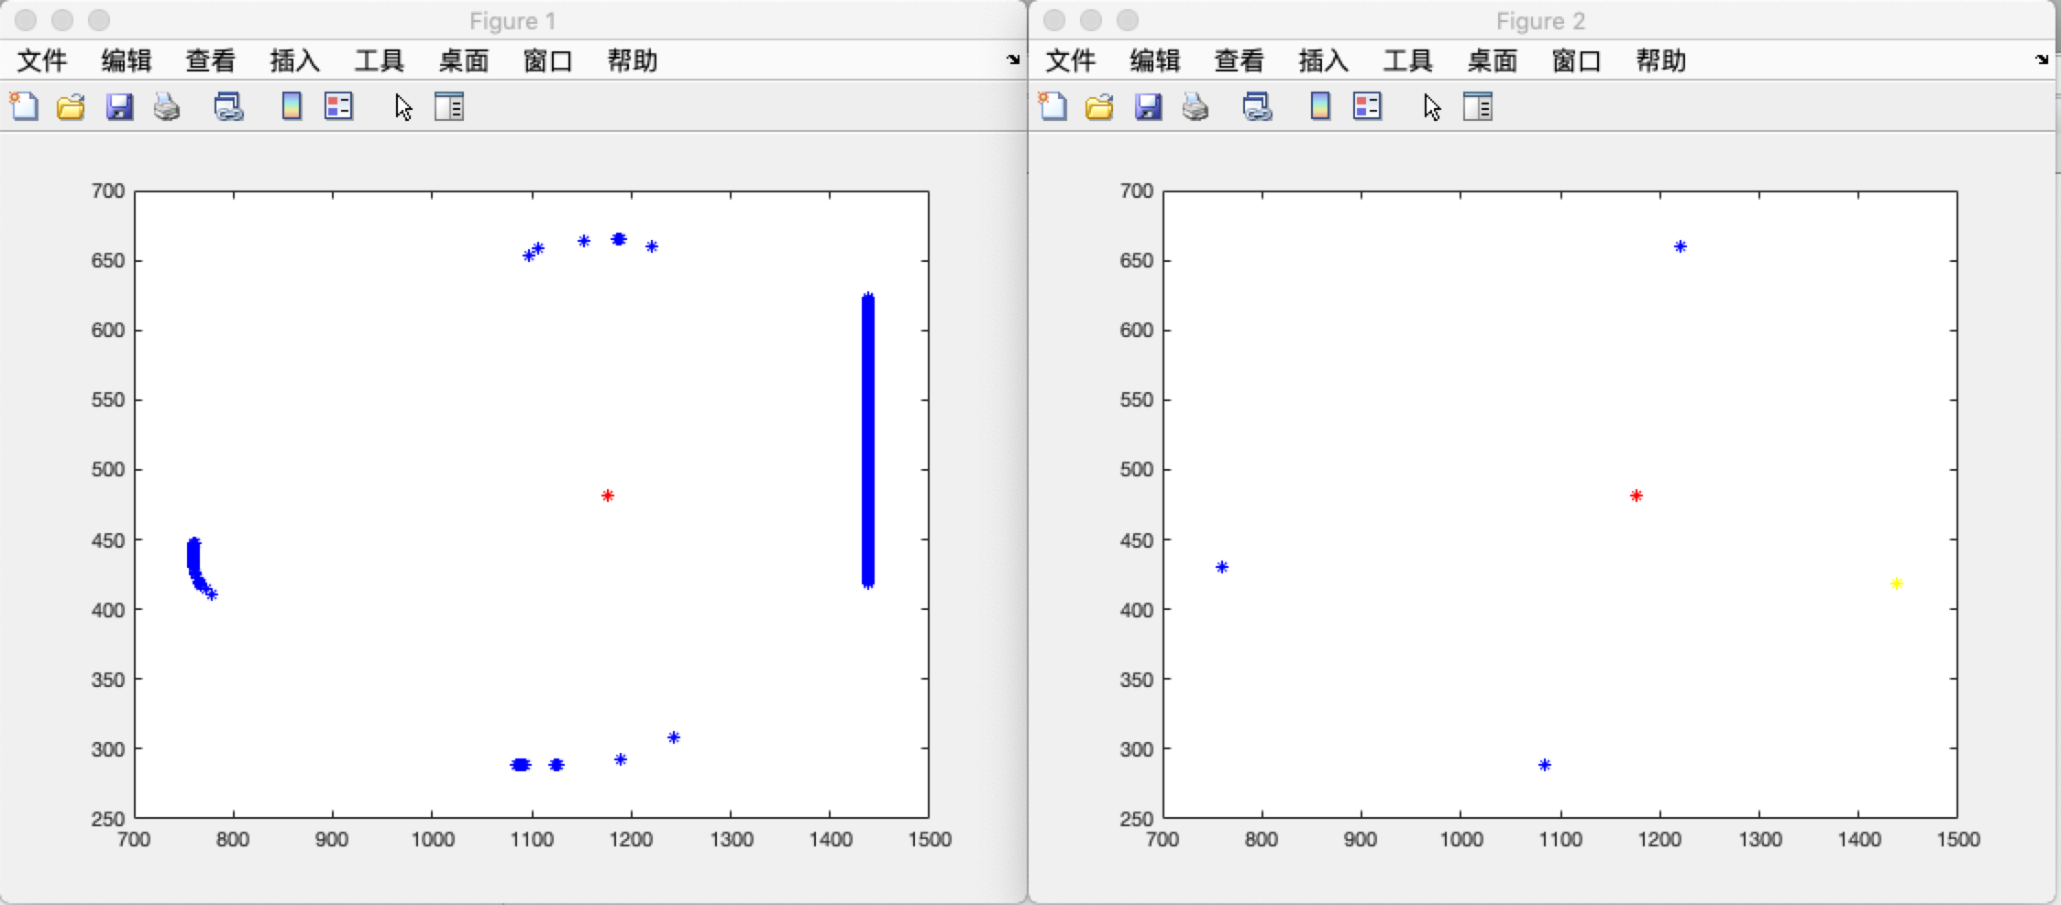

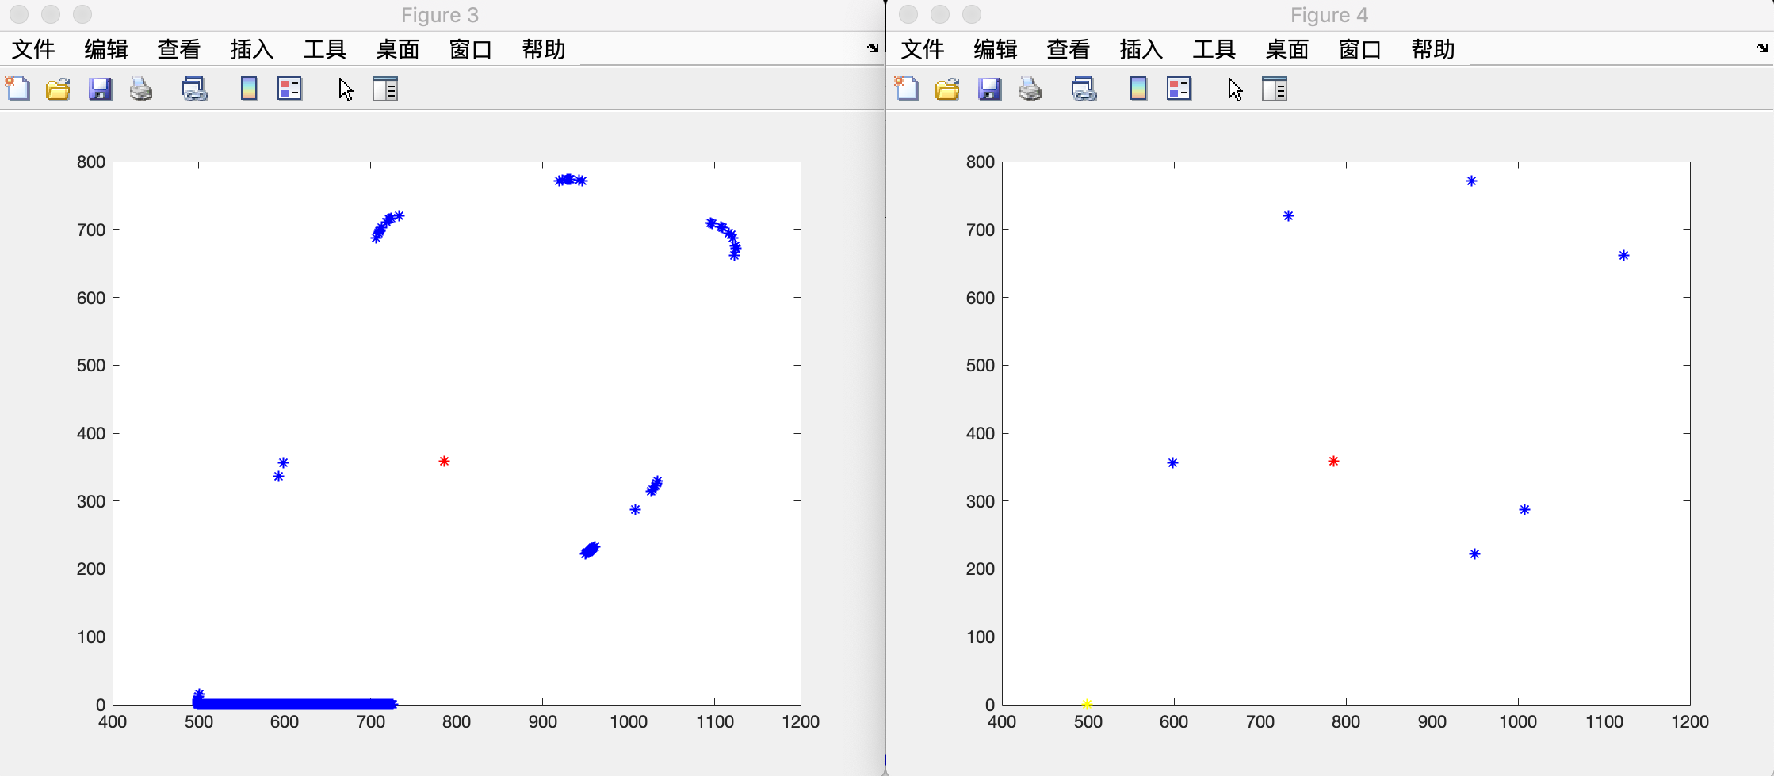

*- Identifying Fingertips*

Finally, we used two factors to identify the fingertips. One is the distance of each convex to the center (denoted as distance below), and the other one is the angle of longest finger, the center, and each convex (denoted as angle below).

This is the major improvement we made to Dr. Prakash’s algorithm which is what we referred to. The original one was getting the radius of the palm area and identifying the fingertips as the distance is larger than the area. But for most of the time we tried, there were many palm contour convex were also outside the palm circle. Below is a picture from Dr Prakash’s paper, and we can see the circle failed to cover the whole palm.

So we figured out a new way to do this. We found that the distances of the fingertips convexes were very close while the palm contour convexes were all shorter than the tips. And there was a floor of the ratio of these two distances. By involving the angle to detect the position of convexes, the accuracy of the algorithm was dramatically improved.

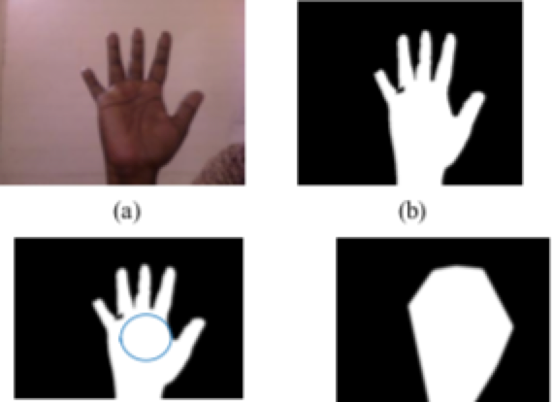

By testing with many different images and learning different kinds of hands, we found the ratio is between 1/1.6 and 1/1.7. With setting the limit that all fingertips’ angle must be smaller than 120 degree, we chose 1/1.7 as our filtering ratio.

***Results***

Here are some results we get for the sample images with one to five fingers postures. The blue dots on the fingertips indicates the existence of the fingers according to our work.

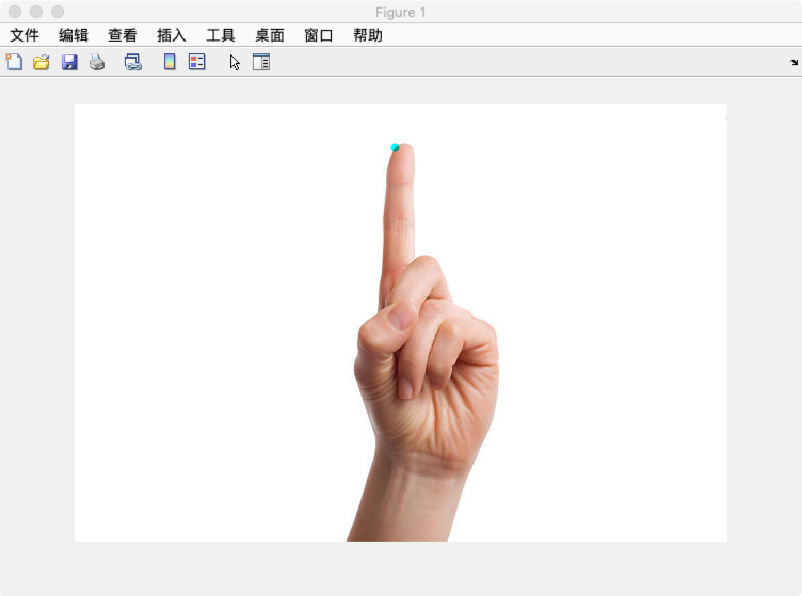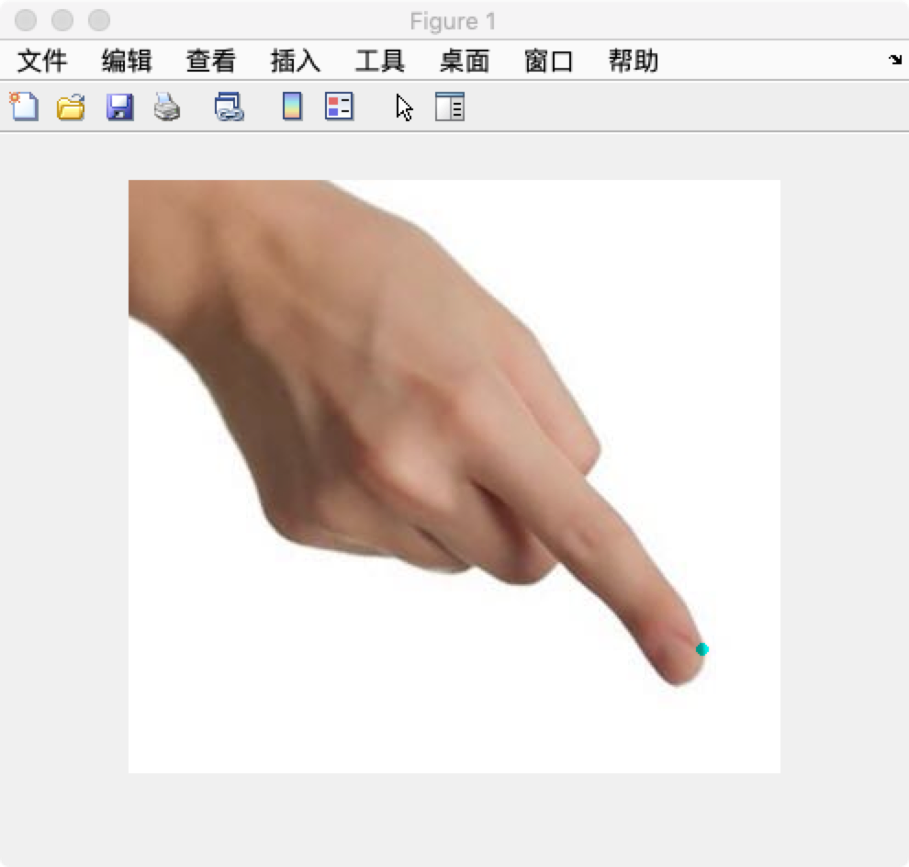

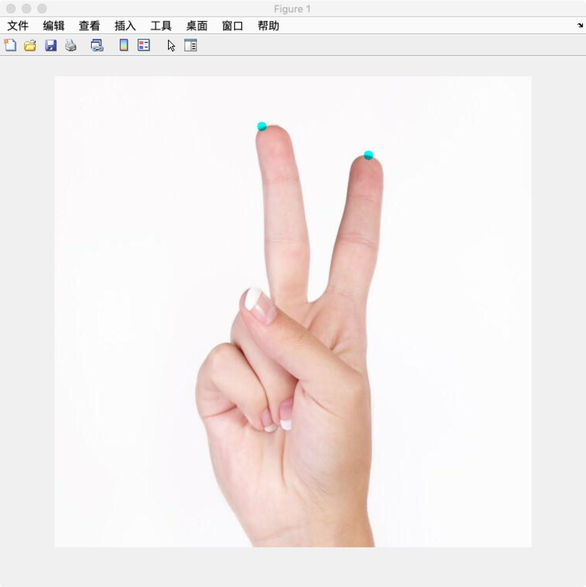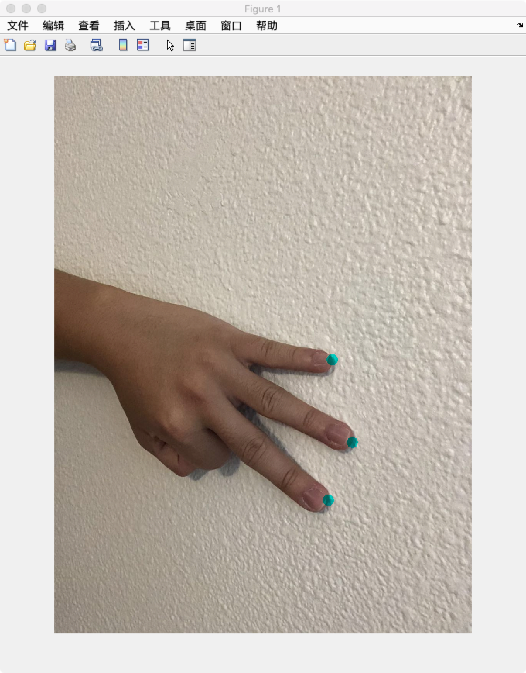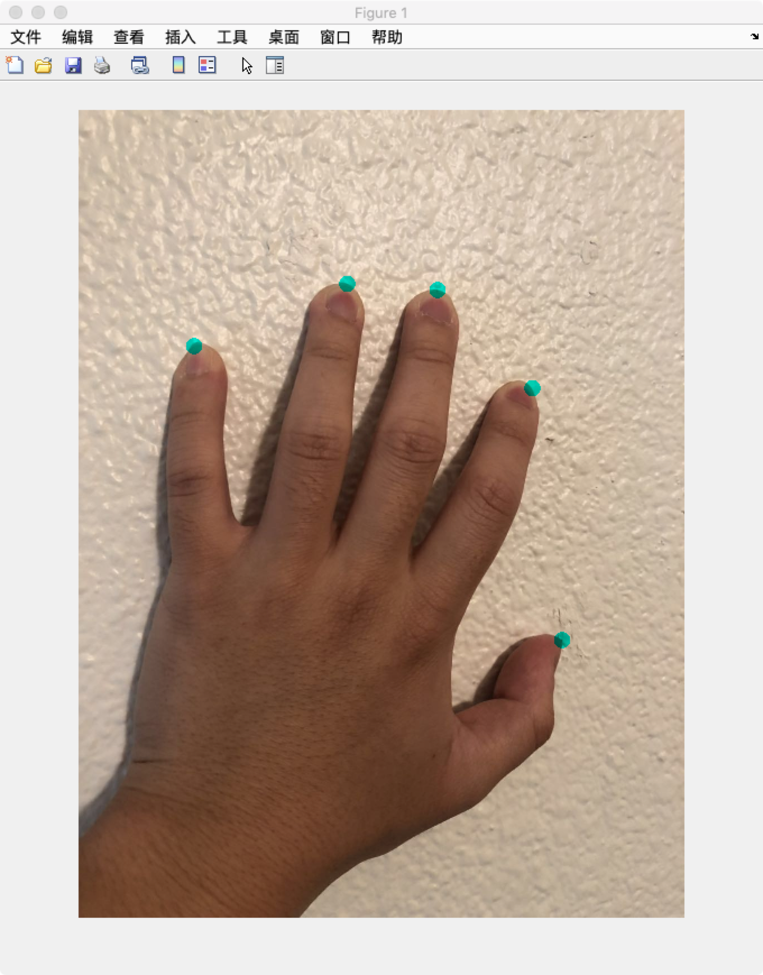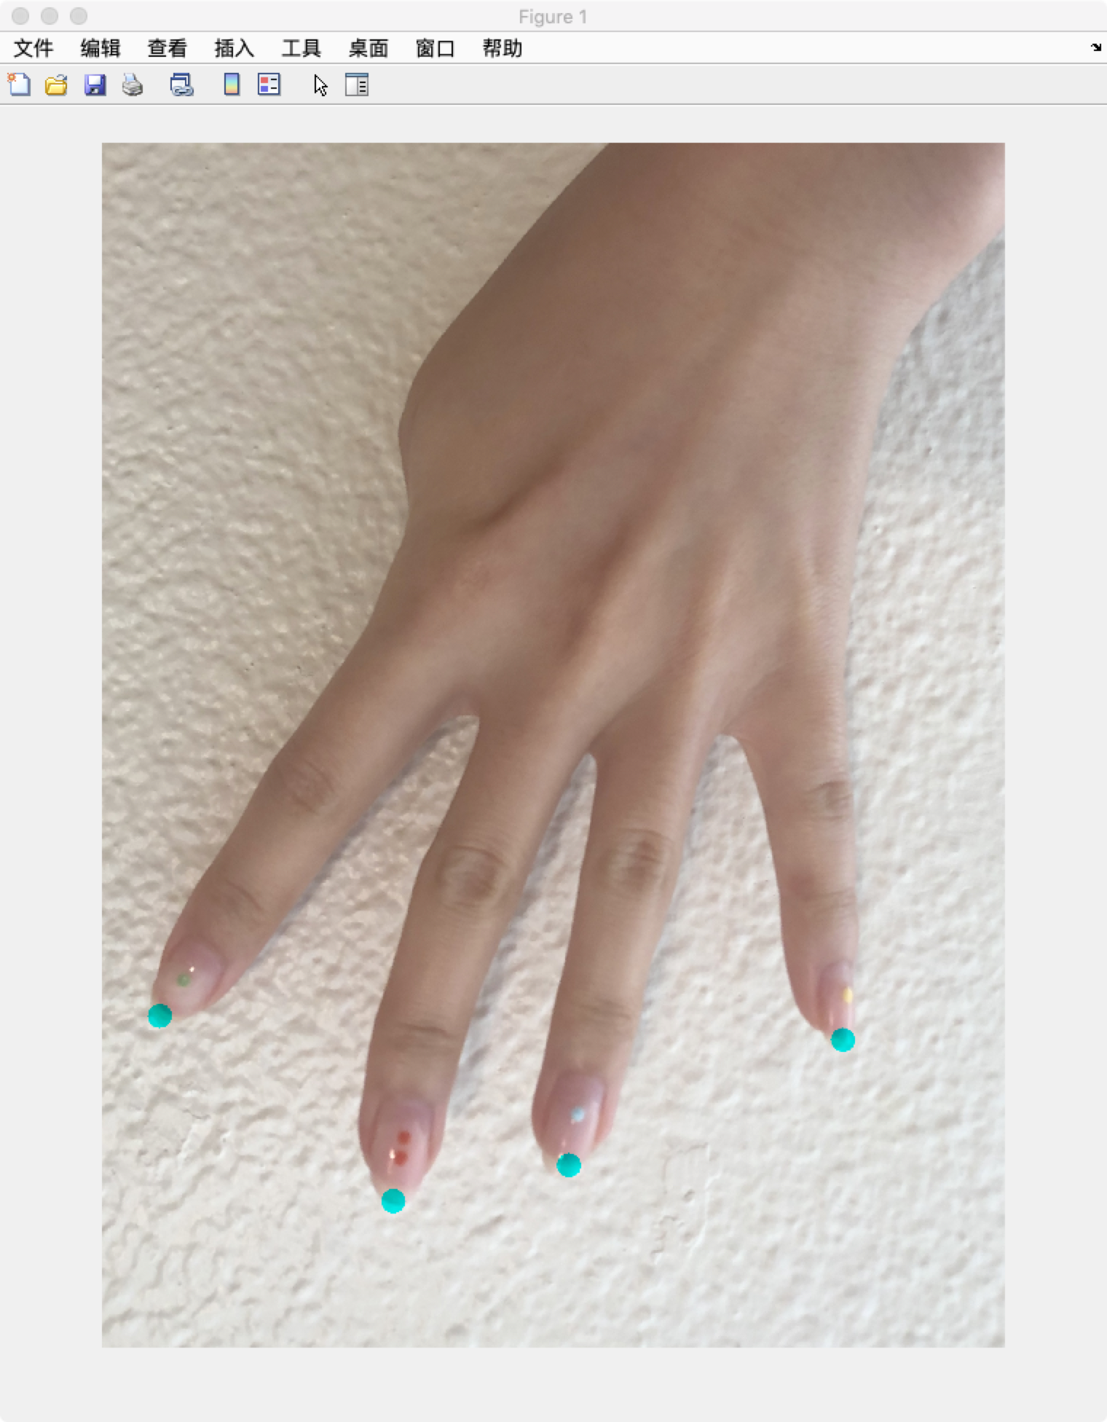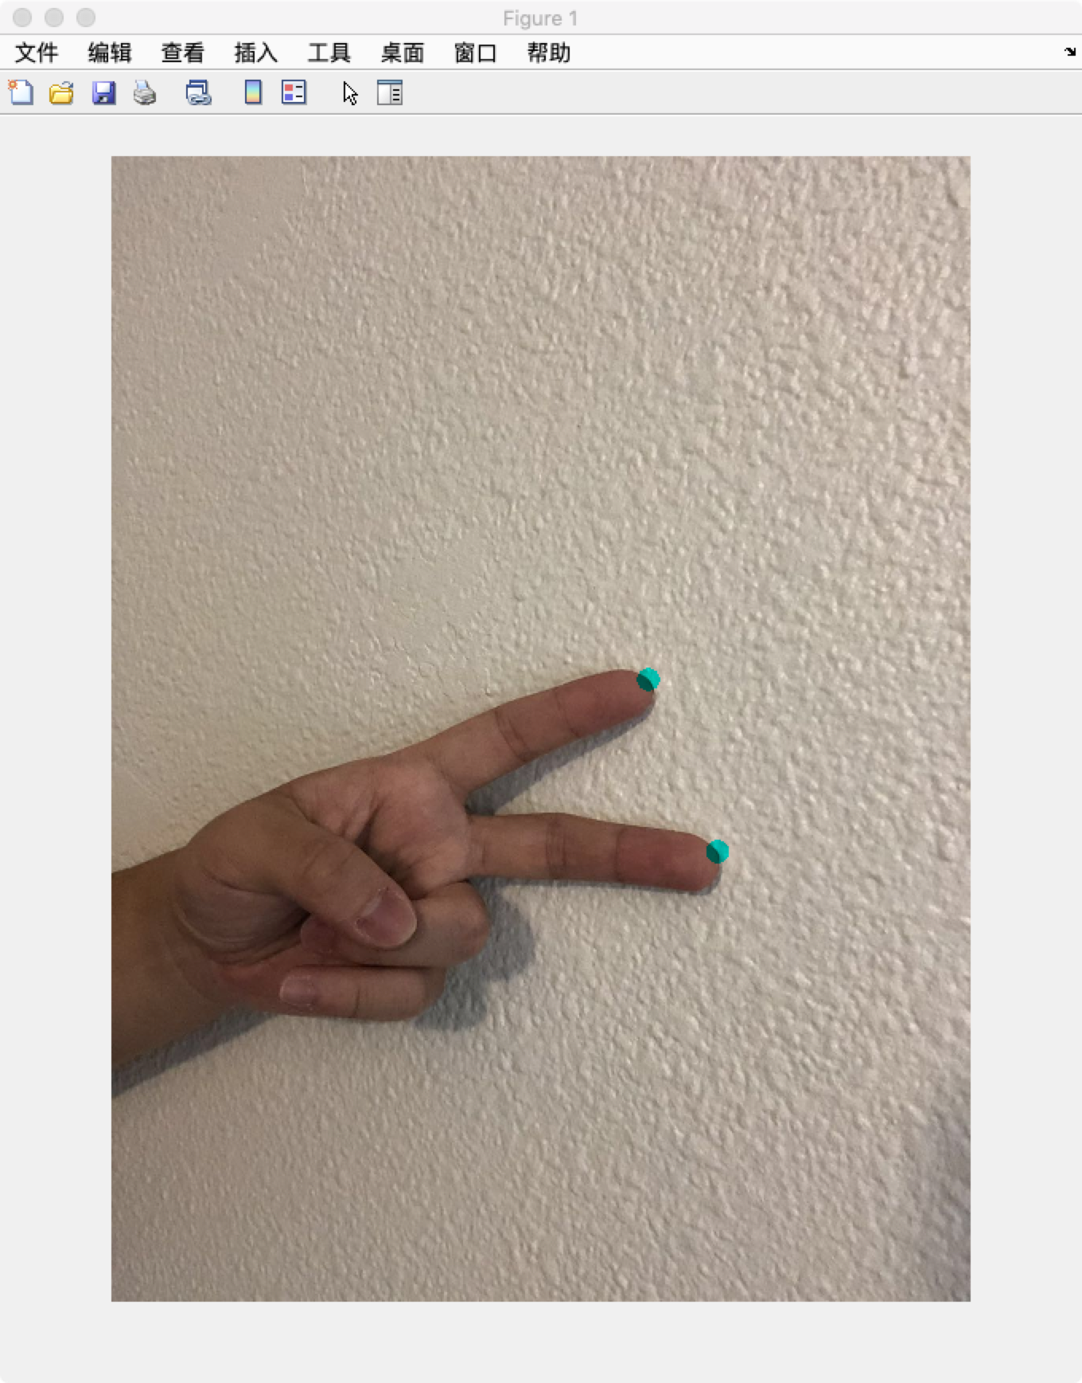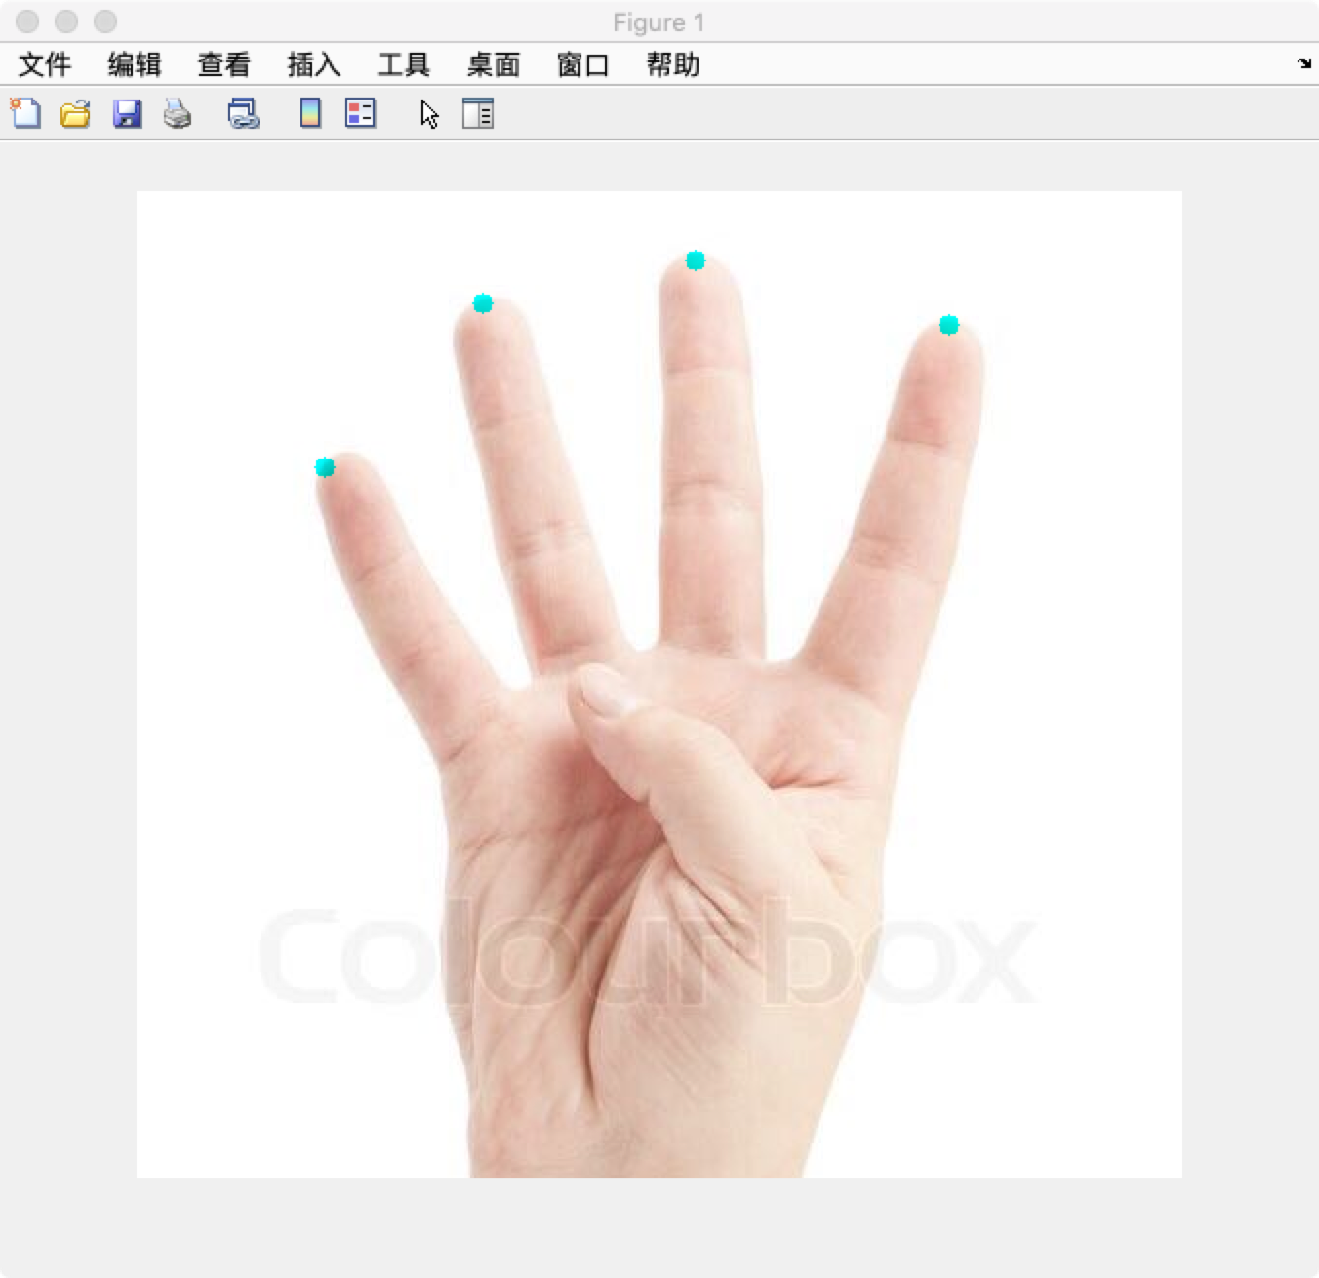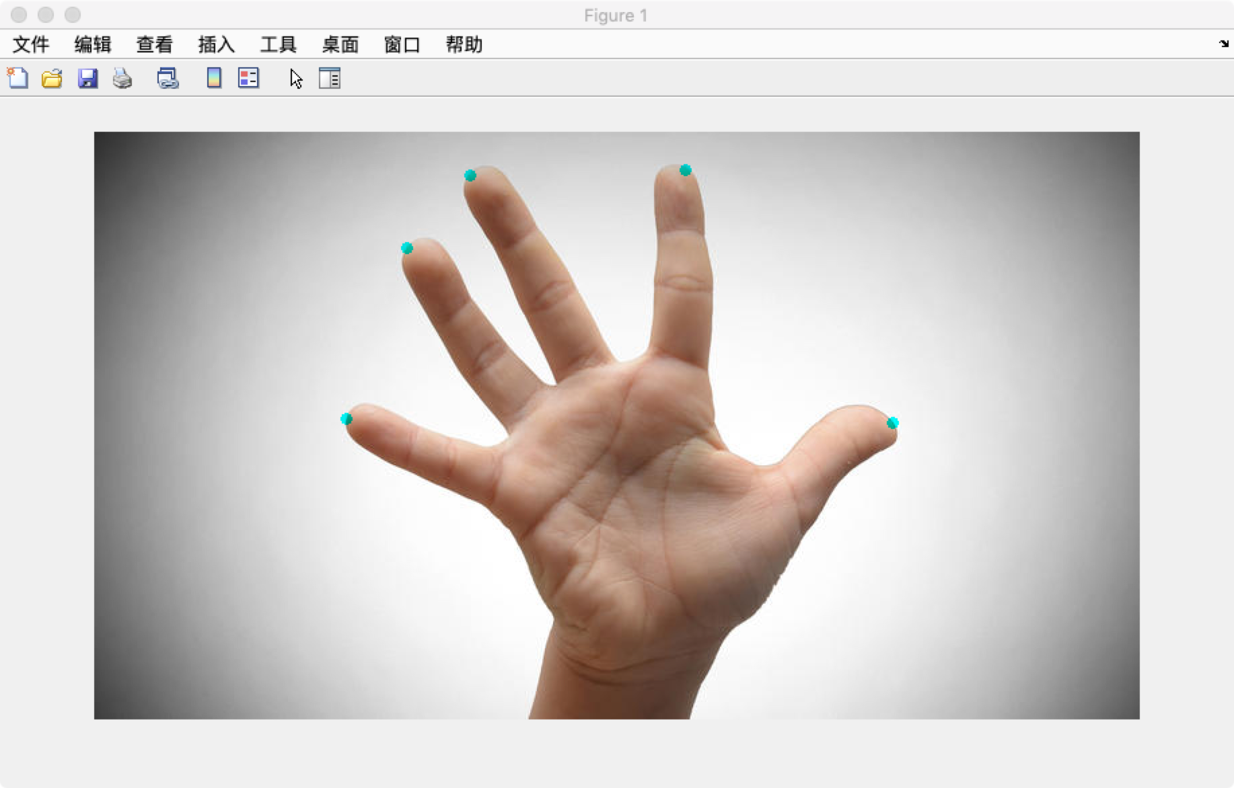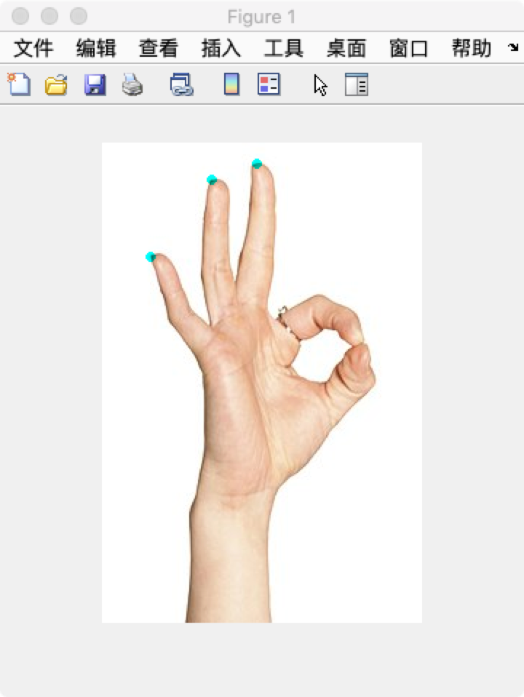

We can see the algorithm works pretty well under different conditions. However we failed one of our testing. As below

There is one dot not even on the hand. Later we found out that was because the shade of the hand was segmented in hand area too. 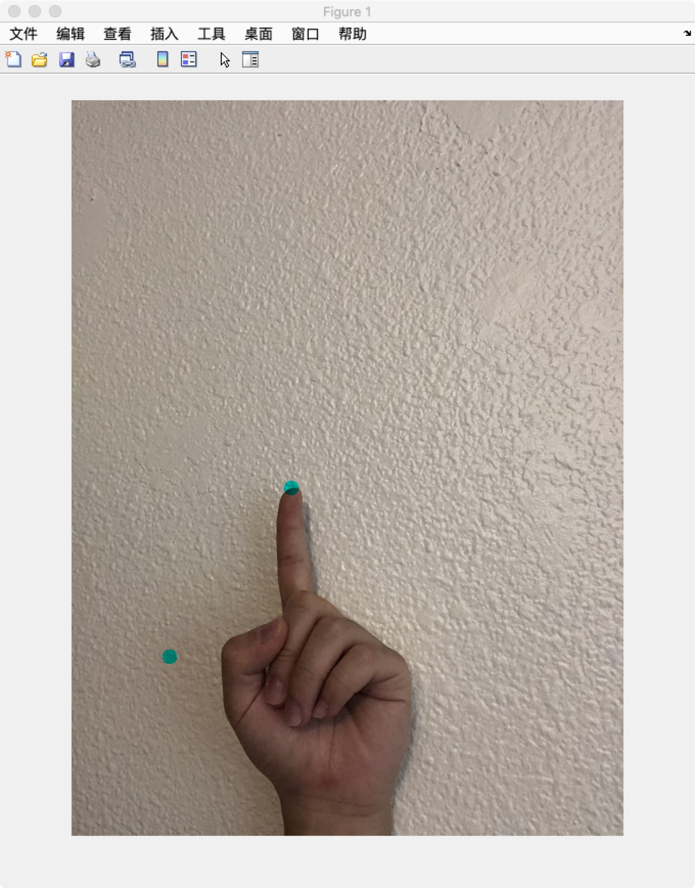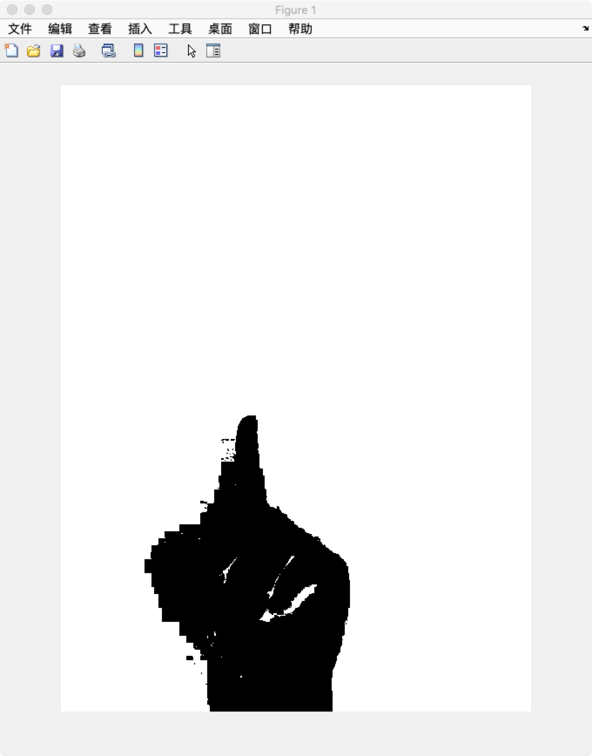

We can see the hand in segmented image is wider, because the shade is included. And therefore one convex on the shade broke the distance ratio and was identified as a fingertips. This revealed that a more accurate segmentation way is needed to make our algorithm better.

***Comparison***

In order to compare our work against similar approach, we tested our by five different hand gestures. Our method performed in an efficient and accurate way while dealing with only the processed depth images.

For the comparison part, we found that Yash’s work of real-time finger extract with background subtraction would be a great method to compare with (“Image Processing Hackathon - detection of number and order of bent fingers”). There are both similarities and differences between Yash’s work and ours. Yash’s work is a good example of how real-time hand gesture recognition will look like, which we can extend in the future. In his work, it requires the first seven seconds to get the average date of the background. During this process, the users need to keep their body parts out of the range of the camera the whole time. Then, it will calculate the average background data and subtract it from the individual video frame taken by the camera. His algorithm uses a skin segmentation which is also based on color differences to find the contour with the largest connected area, which is the hand area, instead of a color based segmentation as we use for our work. The skin segmentation in his work uses a linear decision boundary classifier, which is clustering the skin and non-skin by setting a fixed-range skin color map and fixed skin thresholds. There are also many other kinds of skin segmentation classifiers such as Bayesian classifier. There are some trade off between the accuracy rate and the time complexity of the classifier he uses. Since it is relatively faster than Bayesian classifier with less calculations, it seems not very accurate and stable while detecting the fingers. During his video demo, there are many regions are not fingers but have been marked red as showing below:

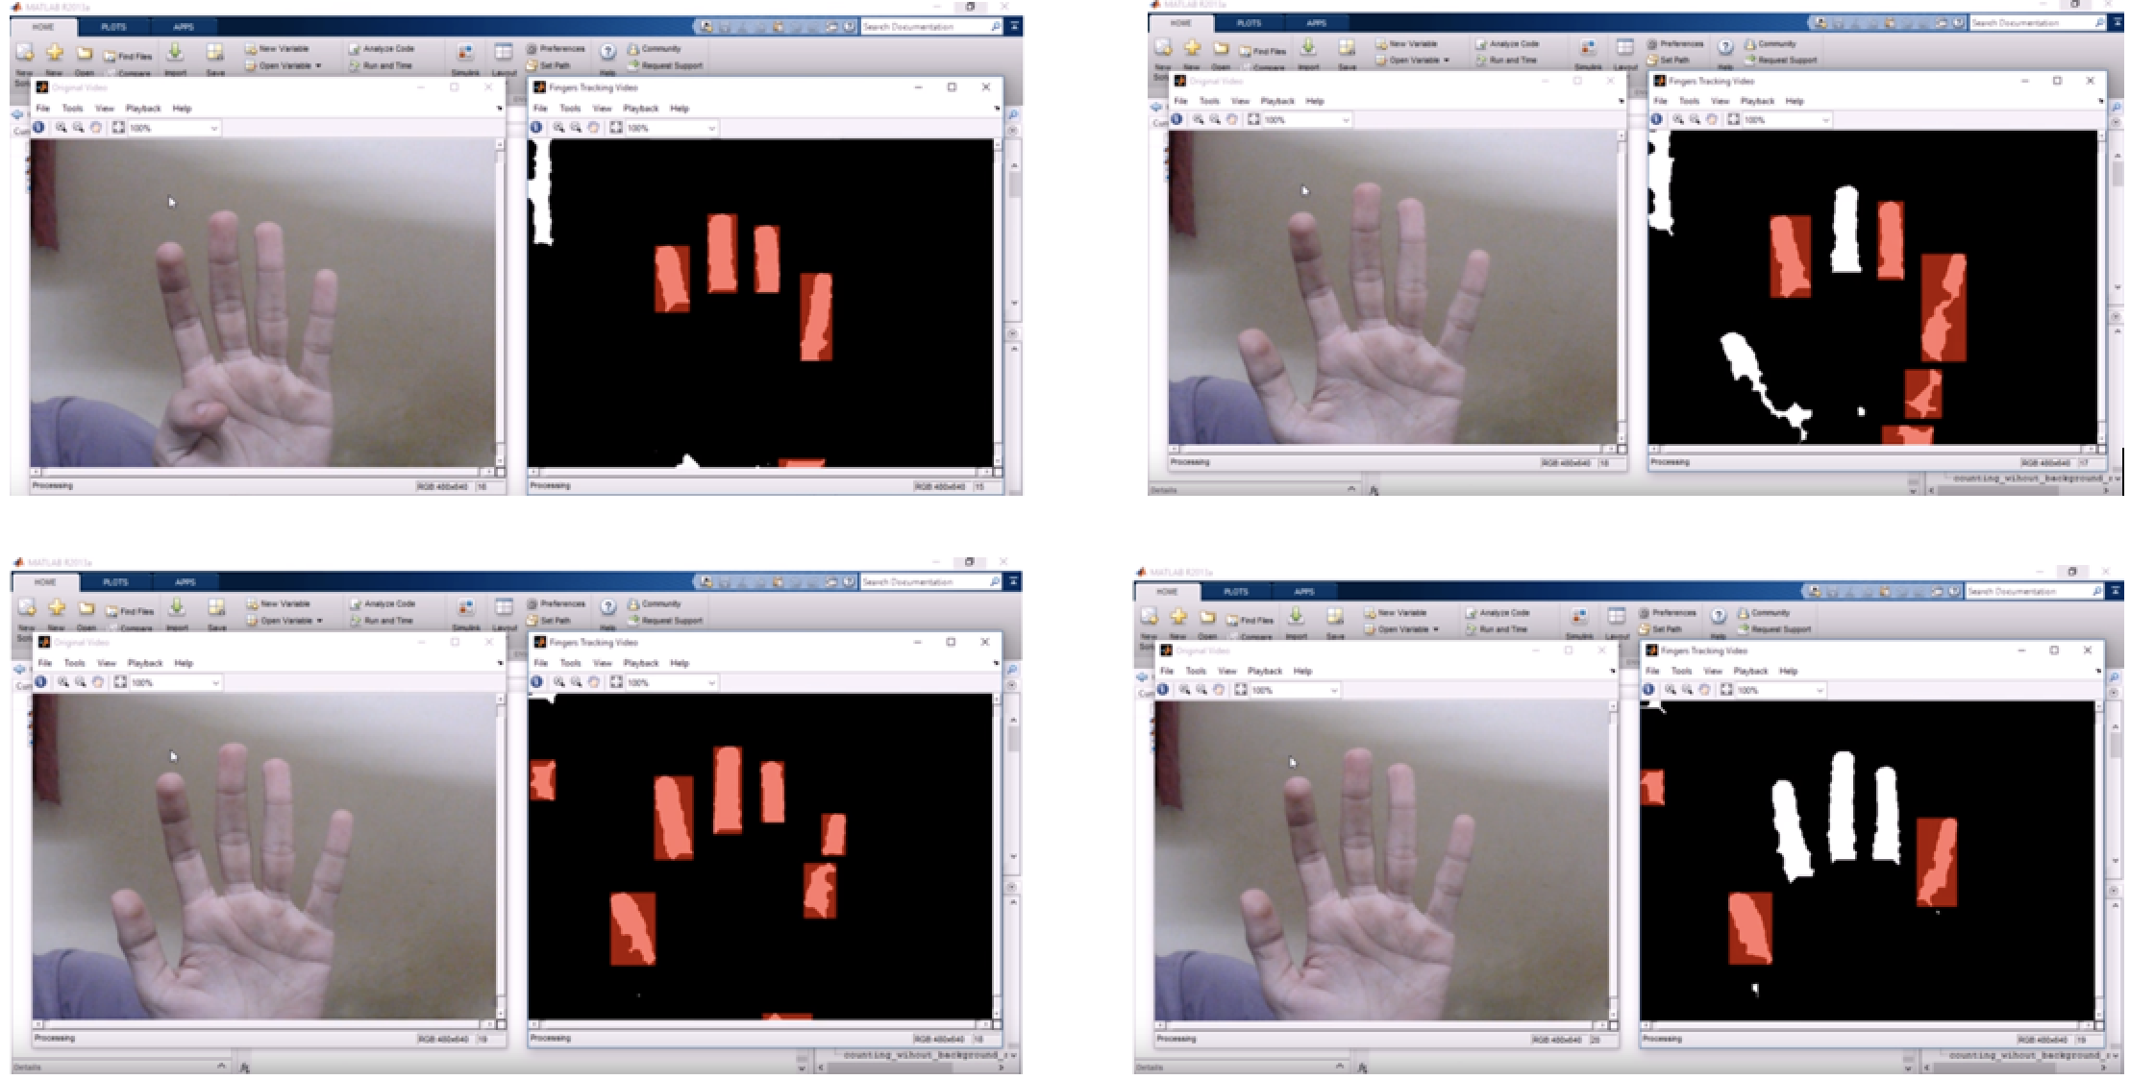

With the color based segmentation we use, the hand area can be easily subtracted from the background with just a few calculations. It is an efficient and accurate solution when comparing to Yash’s work.

***Evaluation***

We have designed and developed a method to detect the hand gestures of one to five fingers. The work is an accurate and efficient solution for future interaction between human and computer devices. It is user friendly and no-need of complex equipment. There are still some limitations of the work that we can make improvements on in the future. For instance, we can include machine learning and train our gesture classifier in order to increase our recognition rate, or applying a better segmentation algorithm as mentioned above. Overall, it worked greatly, and it explored the field of body detection of human-computer interaction.

Work Cited

K. K. Biswas and S. K. Basu, "Gesture recognition using Microsoft Kinect," *The 5th International Conference on Automation, Robotics and Applications,*Wellington, 2011, pp. 100-103.

R. M. Prakash, T. Deepa, T. Gunasundari and N. Kasthuri, "Gesture recognition and finger tip detection for human computer interaction,"*2017 International Conference on Innovations in Information, Embedded and Communication Systems (ICIIECS)*, Coimbatore, 2017, pp. 1-4.

R. R. Igorevich, P. Park, D. Min, Y. Park, J. Choi, E. Choi, "Hand gesture recognition algorithm based on grayscale histogram of the image", *2010 4th International Conference on Application of Information and Communication Technologies*, 2010.

Yash Sanjay Bhalgat, “Image Processing Hackathon - detection of number and order of bent fingers,” *GitHub*, GitHub, 2015